Practice 1:

1. Open this site <https://www.staronline.org.uk/demo_register.asp>
2. Fill in all fields
3. Click Submit (it is just a demo form so nothing should happen)

Practice 2:

1. Must run this on Chrome (not work on FF in 100%)
2. Open <https://login.salesforce.com/>
3. Fill in the User +Password + Remeber me
4. Click on ‘Login’ button
5. Get the error message and print it
6. Click the ‘Forgot your password’ link
7. Insert your name
8. Click ‘Continue’ button
9. Get the error message and print it  
   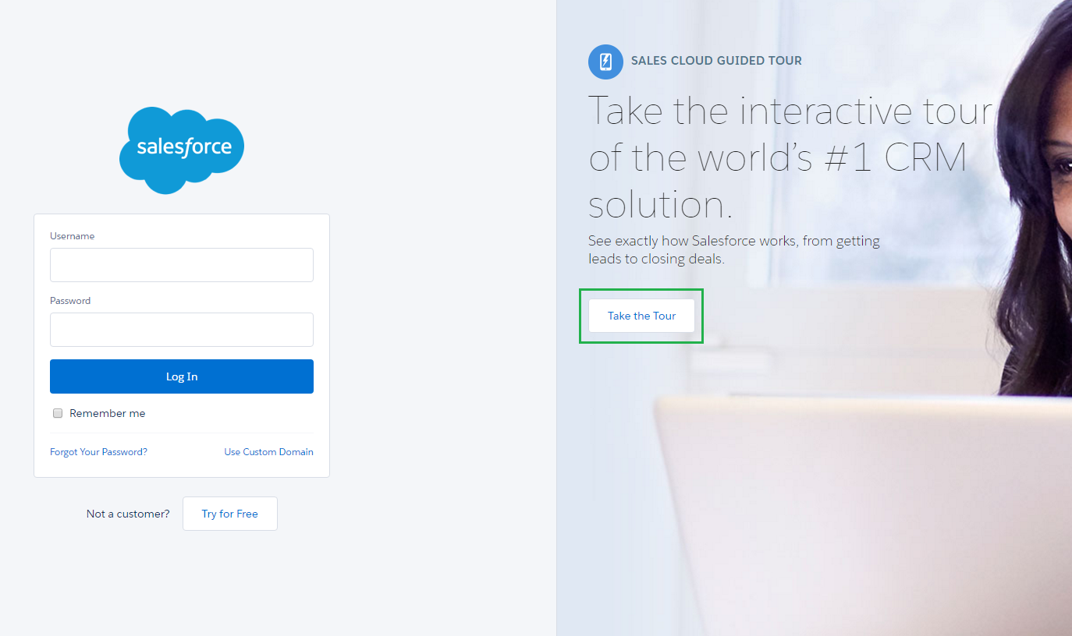

Practice 4:

1. <http://flukeout.github.io/> - CSS - play with this game
2. <http://www.topswagcode.com/xpath/> - XPtah - play with this game

Practice 5:

1. Get all links in this page <http://www.wix.com/jobs/locations/tel-aviv/positions>
2. Get list of all jobs
3. Click on each link, and search for the word “java”
4. Return to the main page
5. Print only the jobs that has ‘java’ in it

Practice 6:

1. Do the same secenario as in proctice #5,   
   but instead of writing everything in the main,   
   create a class with methods that do the scenario.   
   and call the methods from the main.

Practice 7:(challenging)

1. Create a class which has the next methods, and call it from the Main to create the next scenario:
   1. flightFrom(String flightFrom)
   2. flightTo(String flightTo)
   3. departureReturn(String type, String date)
   4. setPassenges(int adults,int children,int infants)
   5. search()
2. Open <https://www.airtickets24.com/>
3. In the search flight area fill in the nexu information:  
   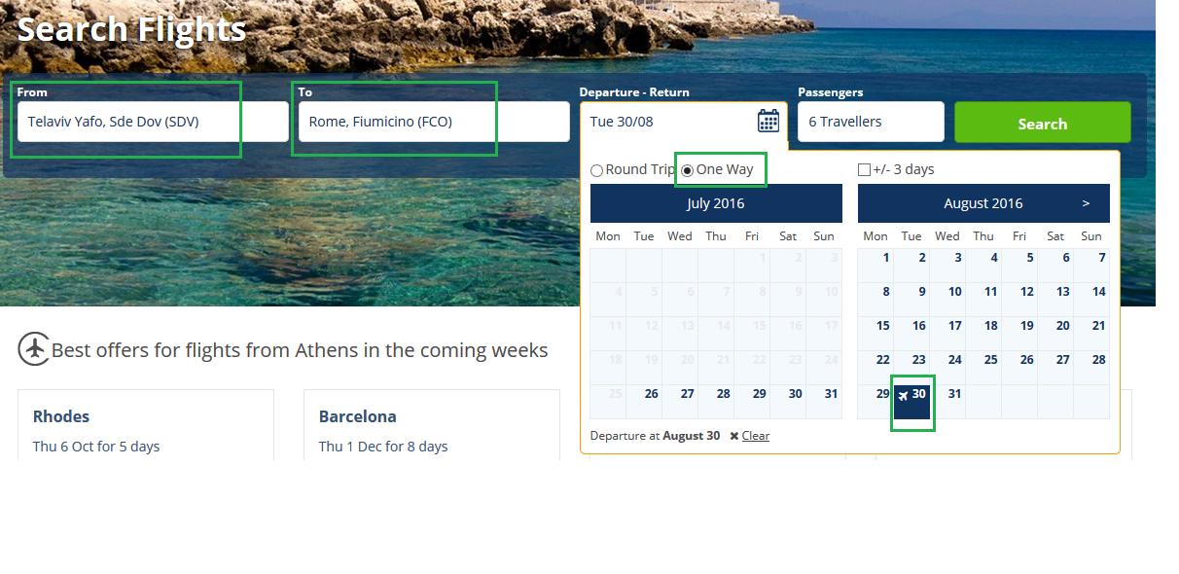
   1. From: Telaviv Yafo, Sde Dov (SDV)
   2. To: Rome, Fiumicino (FCO)
   3. Departure Return: one way, 4 February
   4. Passengers: 6 (like in the picture)  
      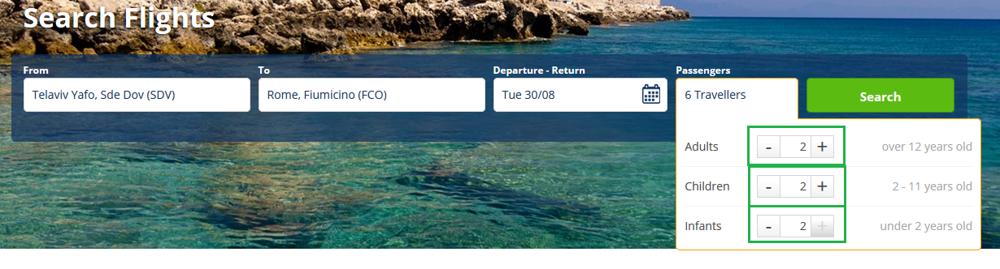

click Search button  
  
Practice 8:

1. Open <http://www.google.com/recaptcha/api2/demo>
2. Click the ‘I’m not a robot’ Checkbox  
   